**ITMD 463/563 Project 5**

* **Goal:** You will be revising your master pages payment calculator using Master Pages and Content pages. The app will be a mortgage calculator application that calculates the monthly payment for a loan based on the principal, number of years, and interest rate.
* **Relevant Example:** See my lecture on MasterPages.
* **Deliverable:** Submit a zip file of your .Net Solution file on BlackBoard using this naming convention: Pro5-Smith.zip (replace Smith by your last name).
* **Changes:** 
  + You’ll replace the file access layer from the previous assignment with the local DB and using Sql Server database classes. The database should have separate fields for principle, interest rate, years and monthly payment. The monthly payment history should look like this

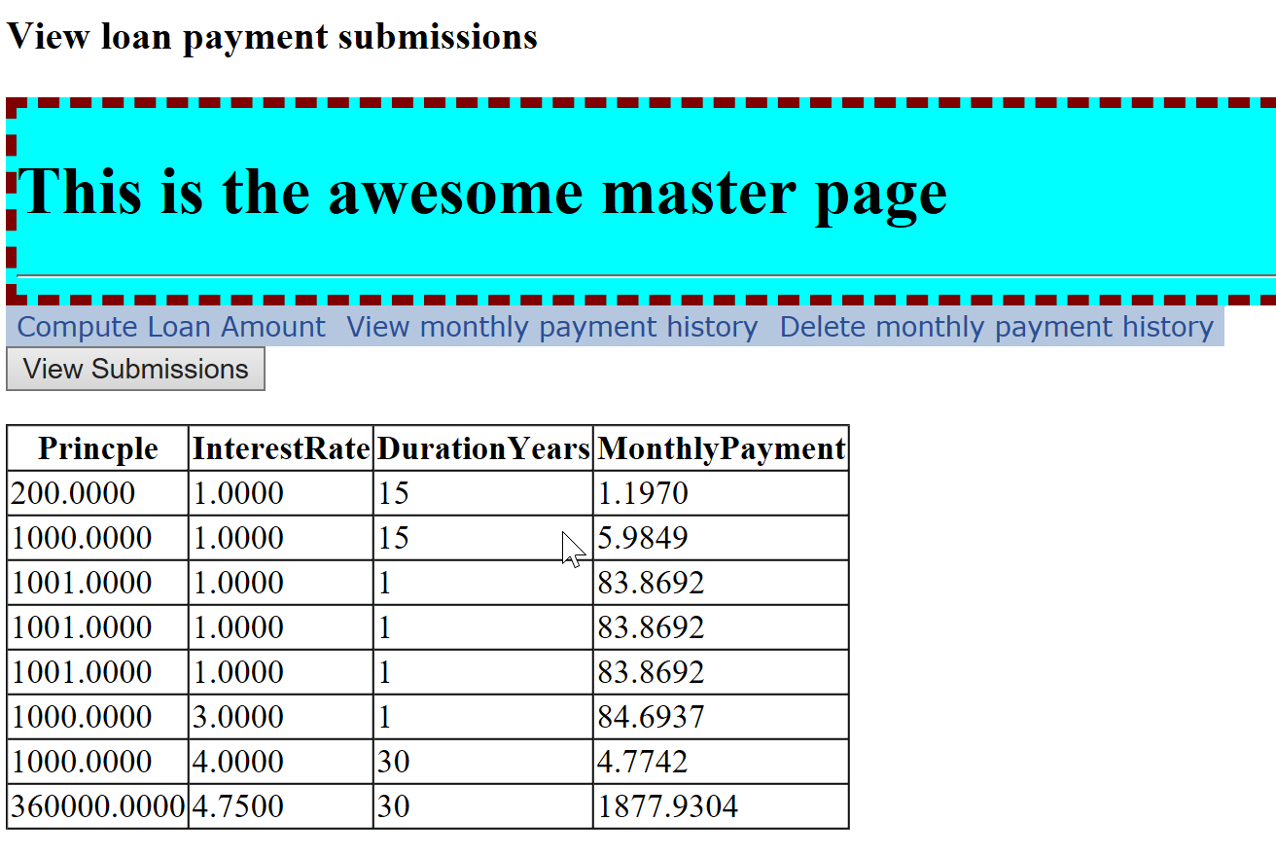

* Check the output with this site <http://www.bankrate.com/calculators/mortgages/loan-calculator.aspx>
* Please use these naming standards for future projects: <http://blogs.msdn.com/b/mschray/archive/2013/05/06/practical-naming-standards-for-c.aspx>
* Is the output clear?
* **Grading:** Per syllabus